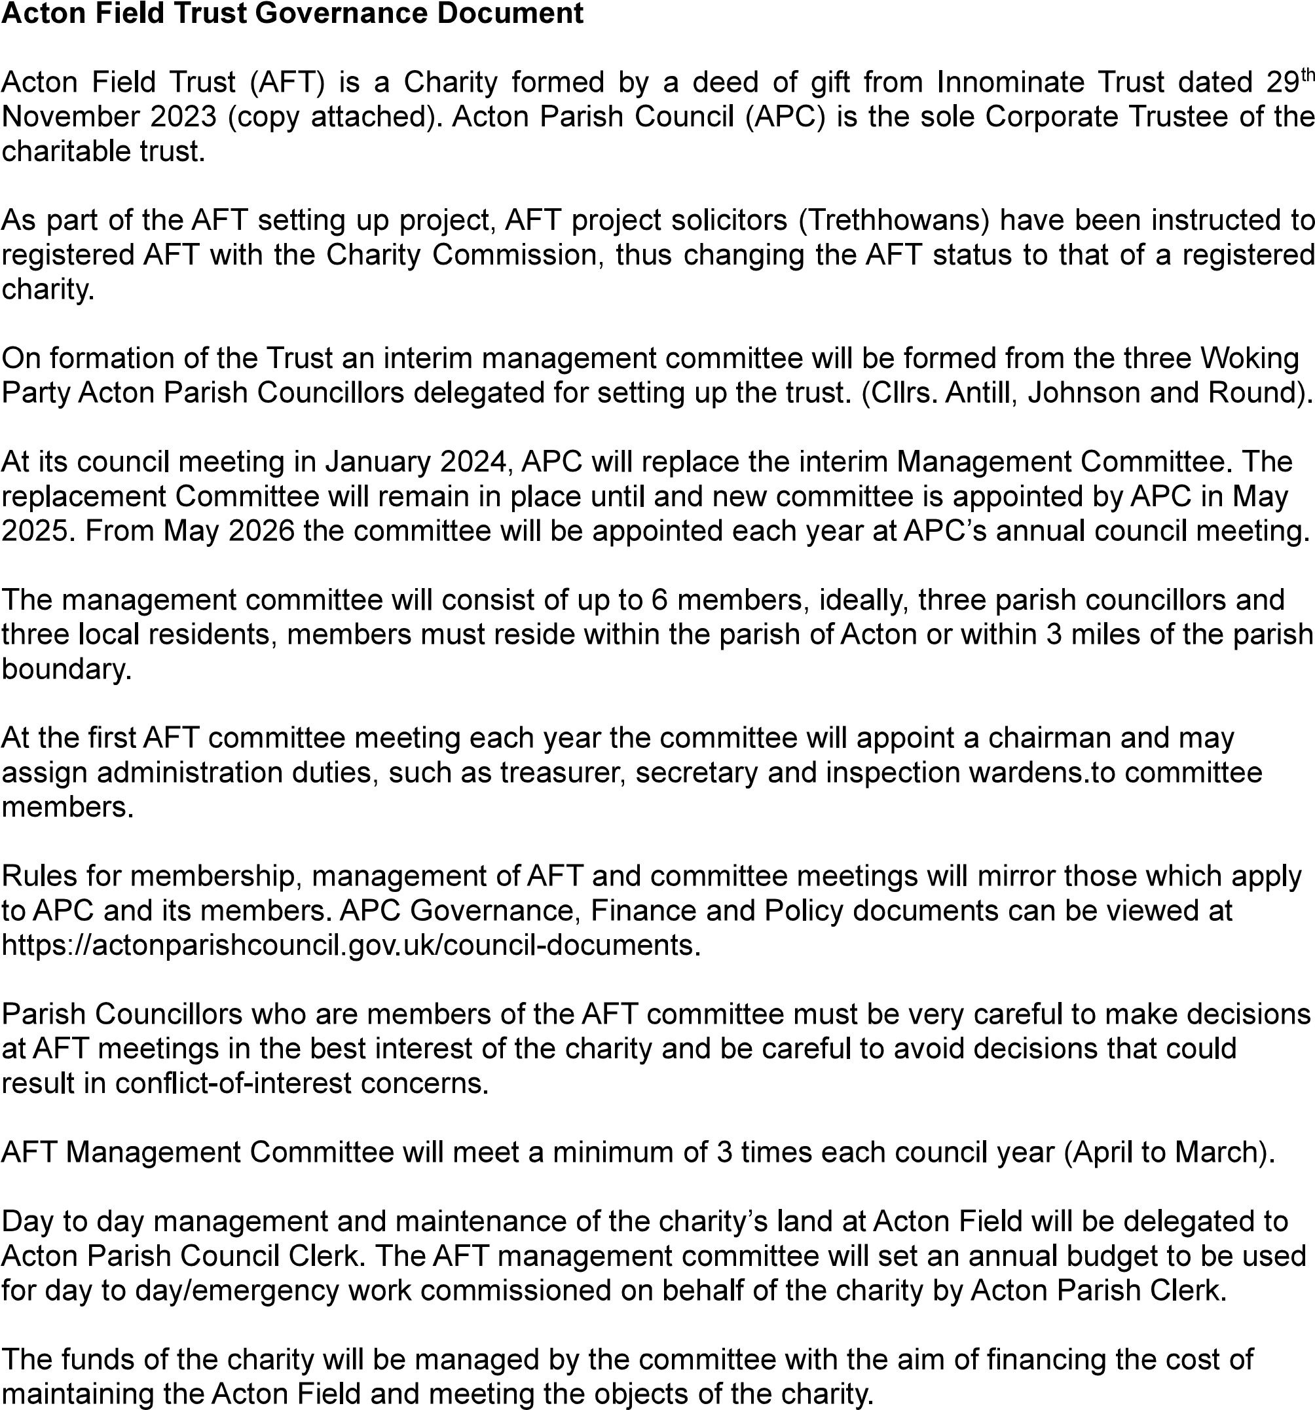
Objects of the Charity as defined in schedule one of the Deed of Gift.
The objects of the Charity shall be for the benefit of the inhabitants of the parish of Acton in the County of Suffolk and the neighbourhood thereof and of those working studying or otherwise for the time being located within the said area to promote all or any of the following charitable purposes:
To maintain a public open space and to provide in the interests of social welfare facilities for recreation and other leisure-time occupation for the use of the public with the object of improving the conditions of the life of such persons; and/or
To promote the protection of wildlife and the protection and improvement of the physical and natural environment; and/or
To advance education, skills and capacity among such persons.
AFT Acton Field Trust - APC Acton Parish Council - Approved by Committee 4th December 2023

